DATABASE: The Complete Oracle SQL Certification

Notes

Creating workspace in Oracle

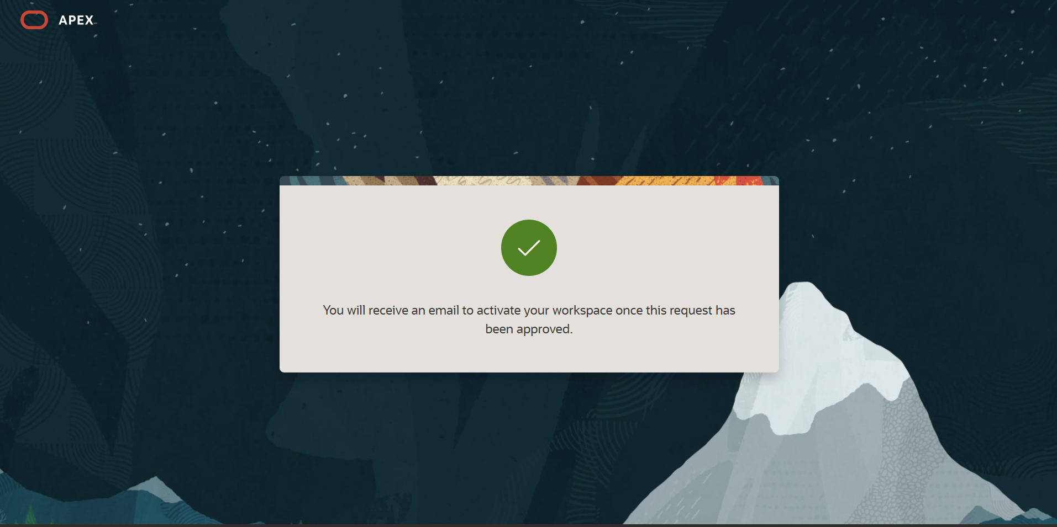

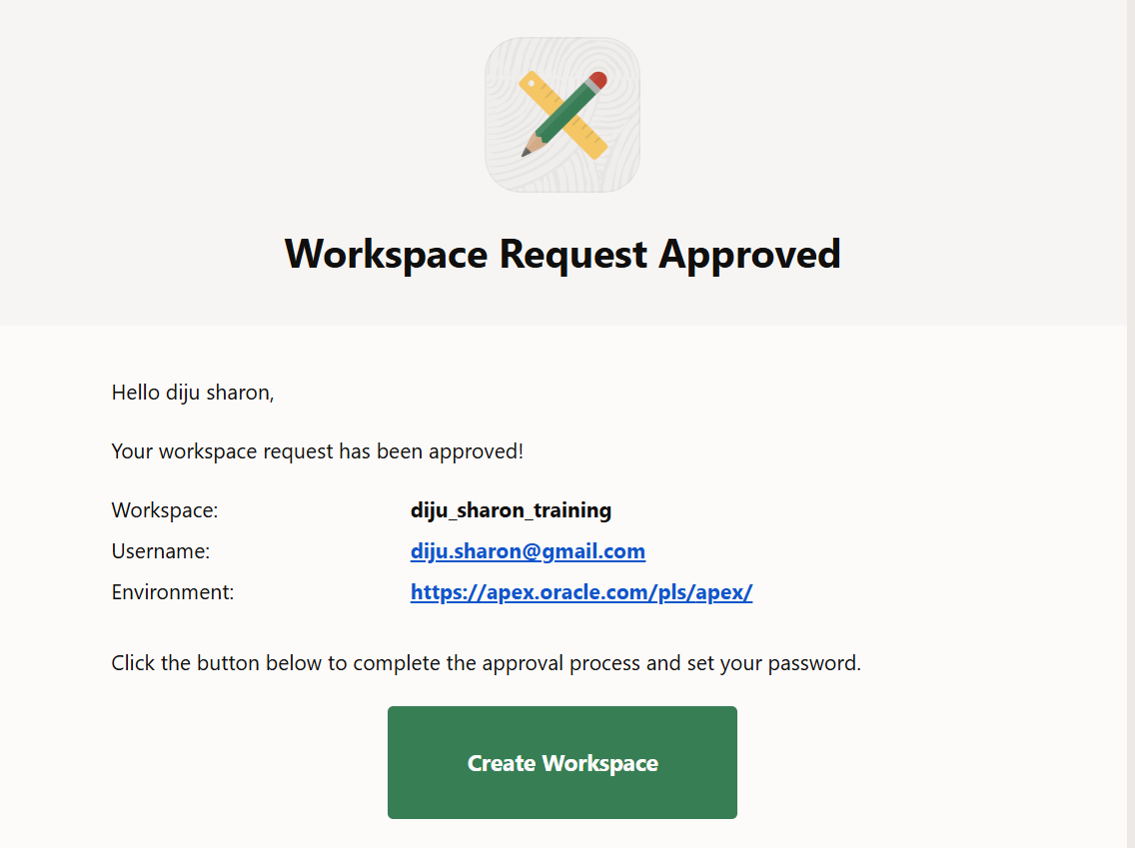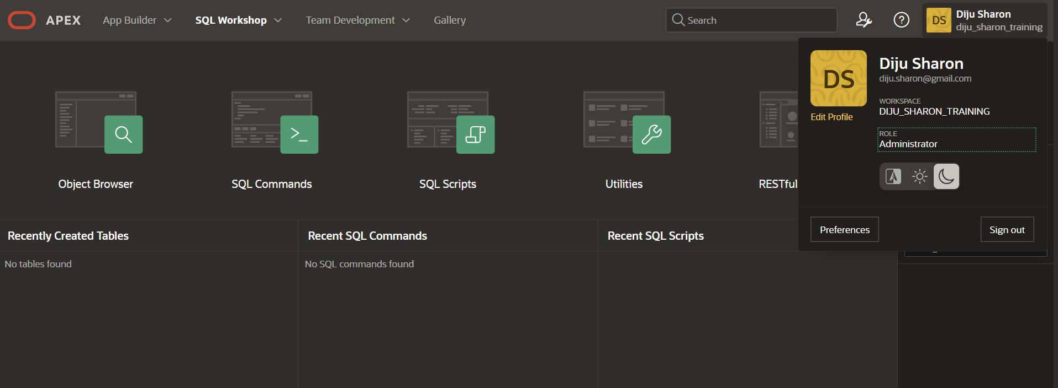

Installed the EMP/DEPT Dataset from Sample Data Sets and the first query has been written.

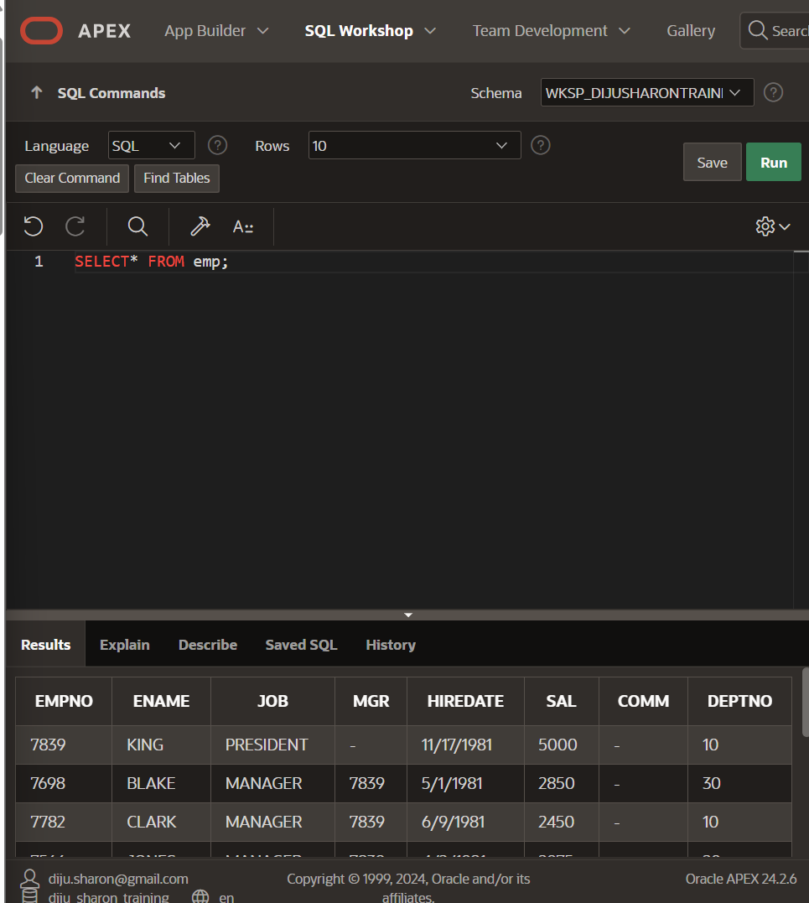

DEPT Dataset consists of three columns: DeptNo, Dname, Loc

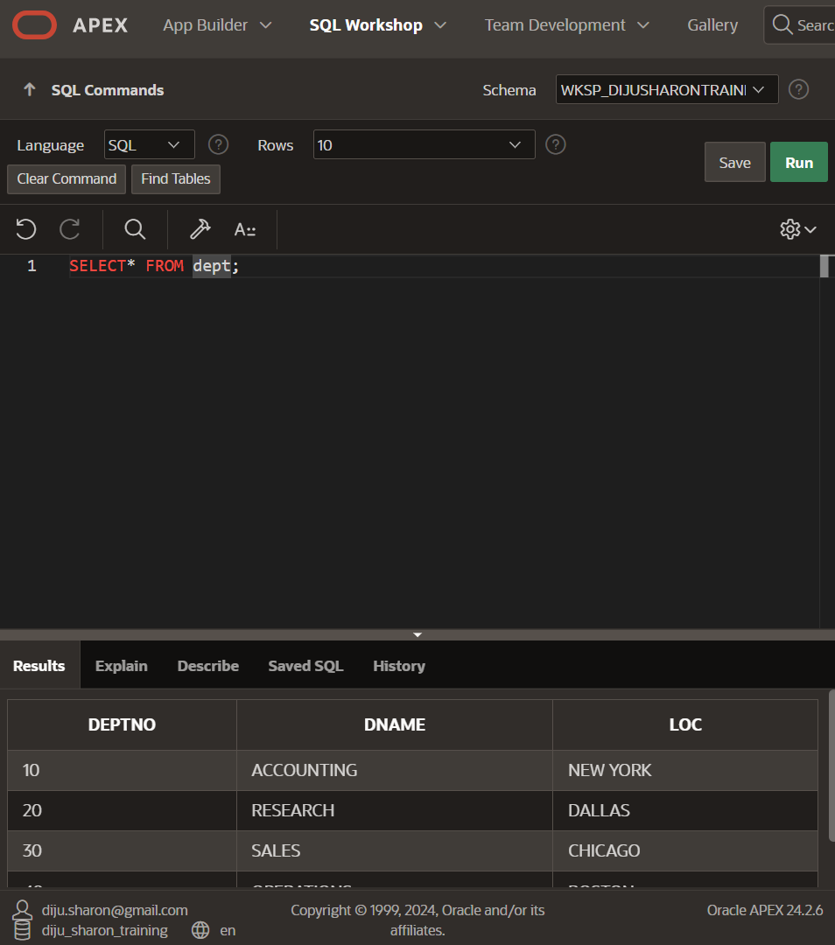

USING SELECT

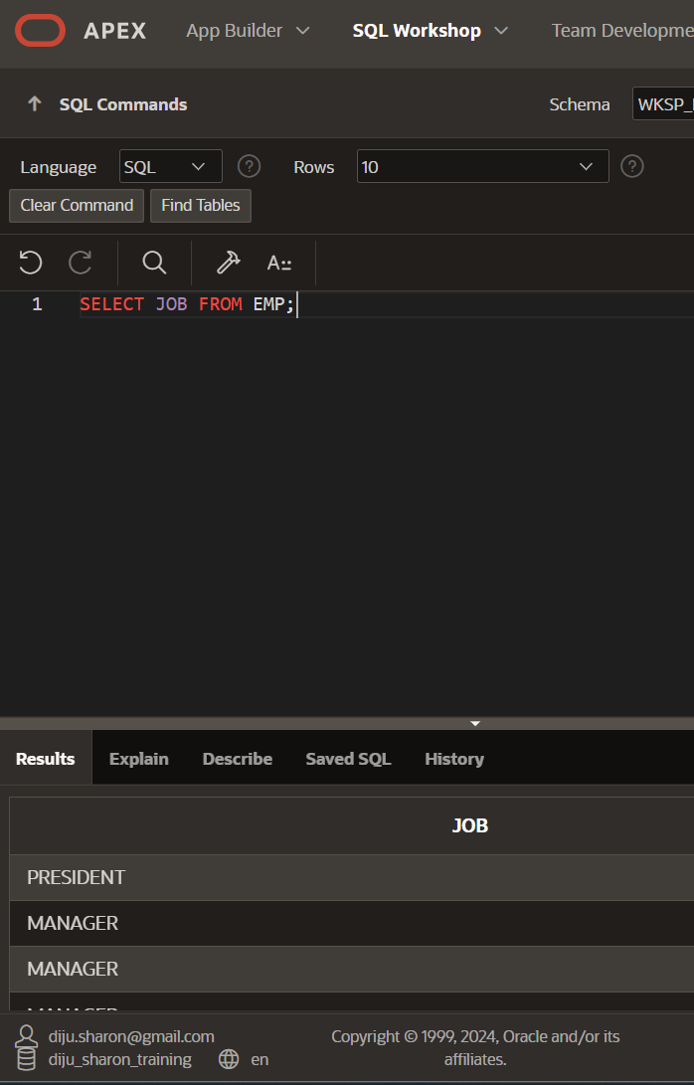

USING THE DISTINCT KEYWORD

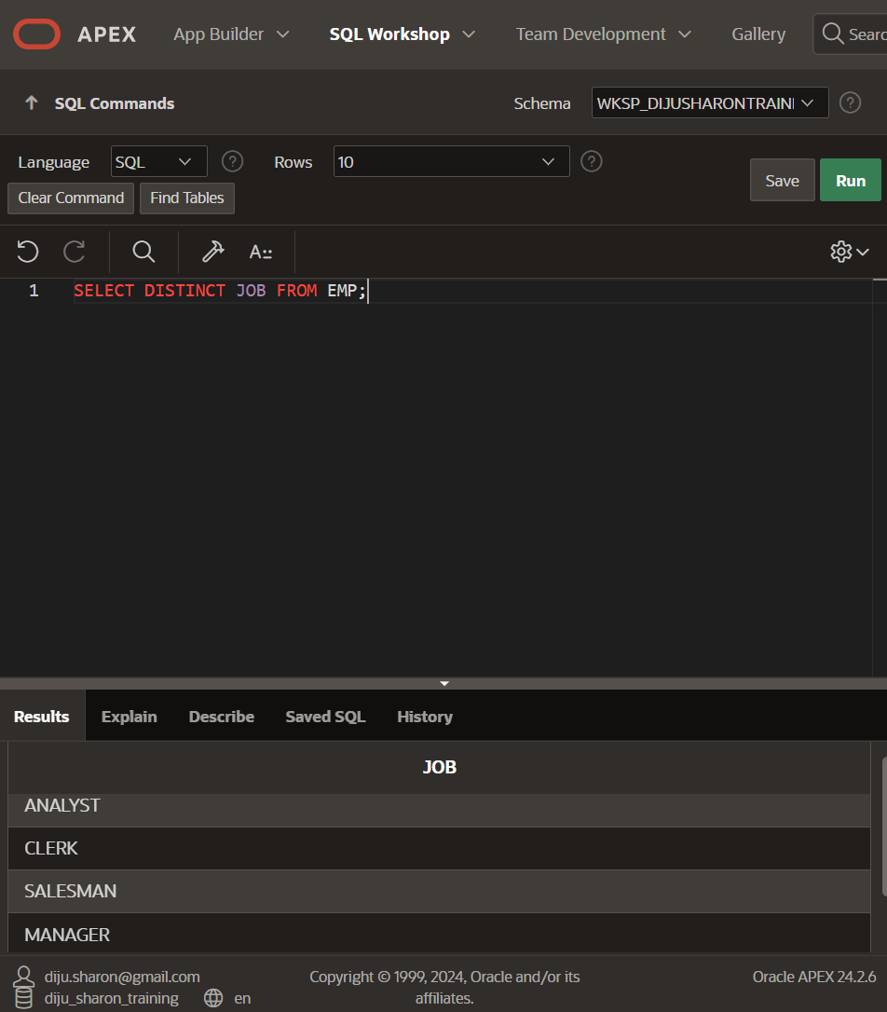

WHERE CLAUSE

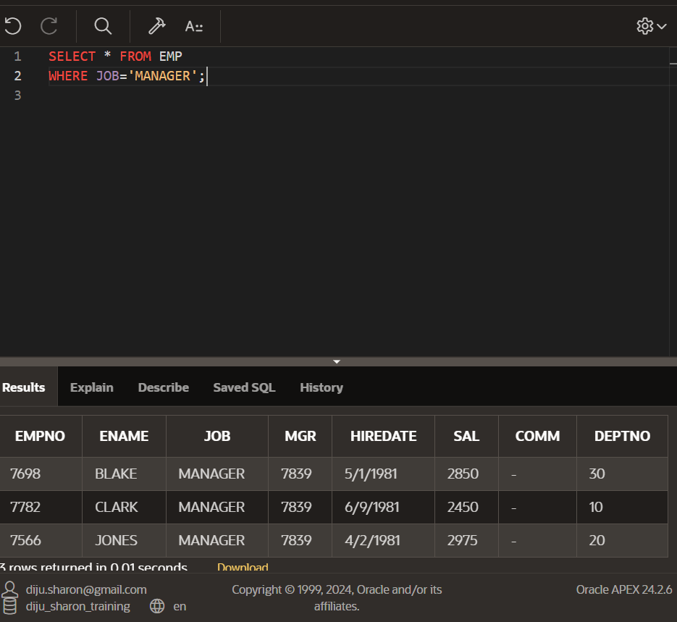

AND CLAUSE

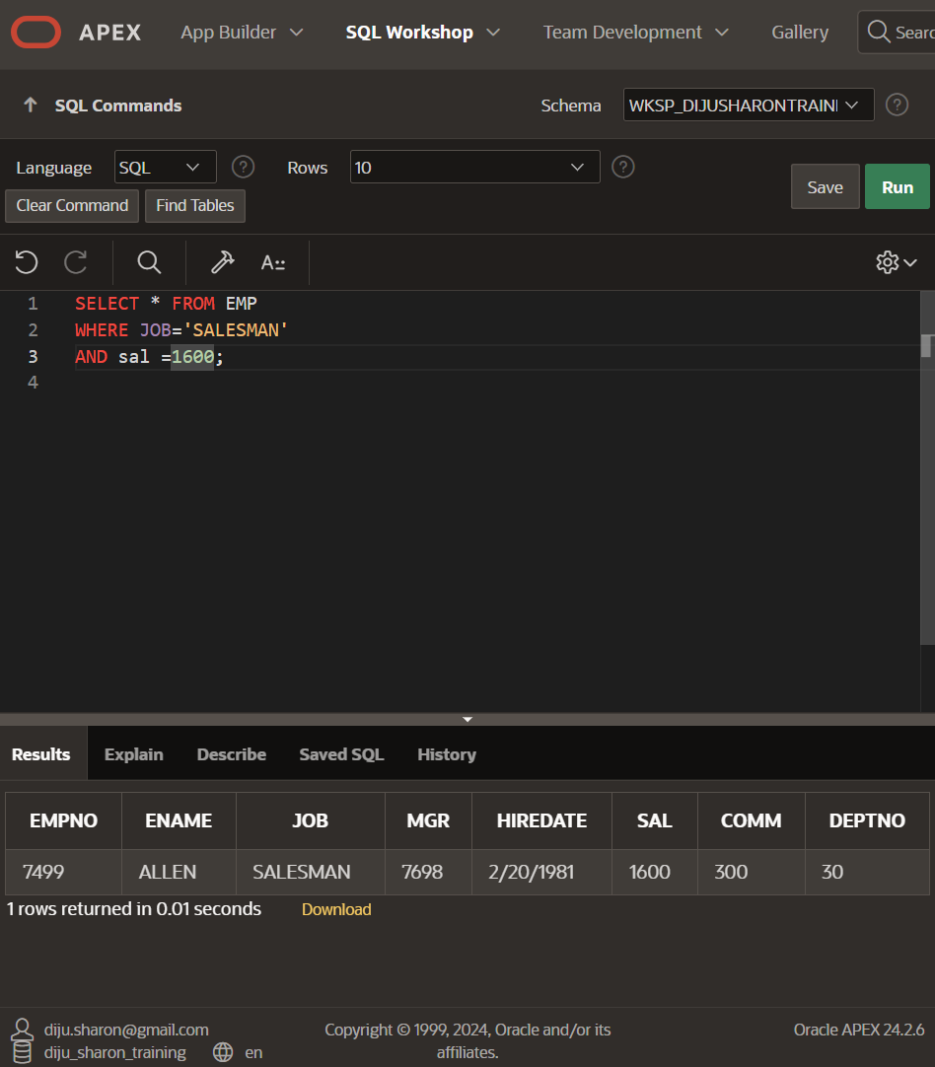

USING COMBINATION OF CLAUSES

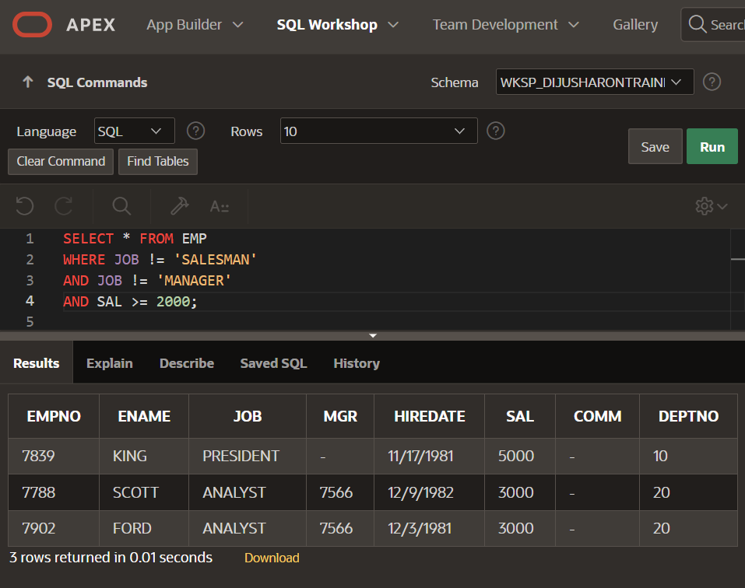

IN CLAUSE

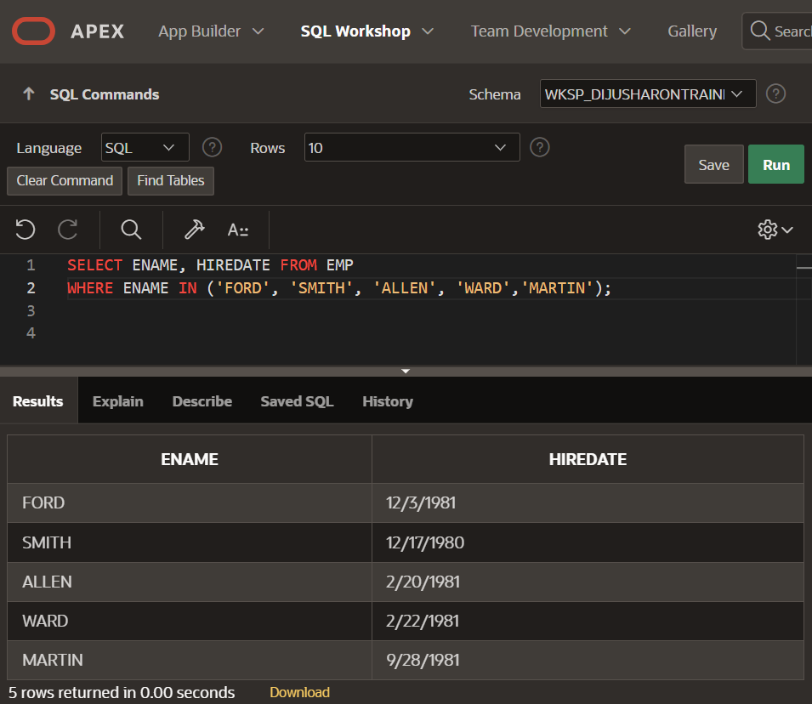

BETWEEN AND NOT BETWEEN CLAUSES

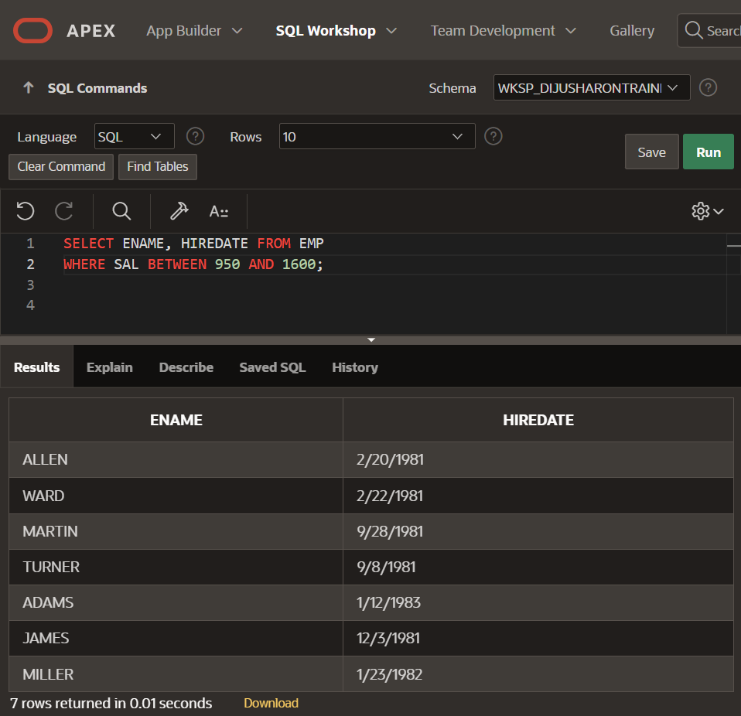

IS NULL AND IS NOT NULL

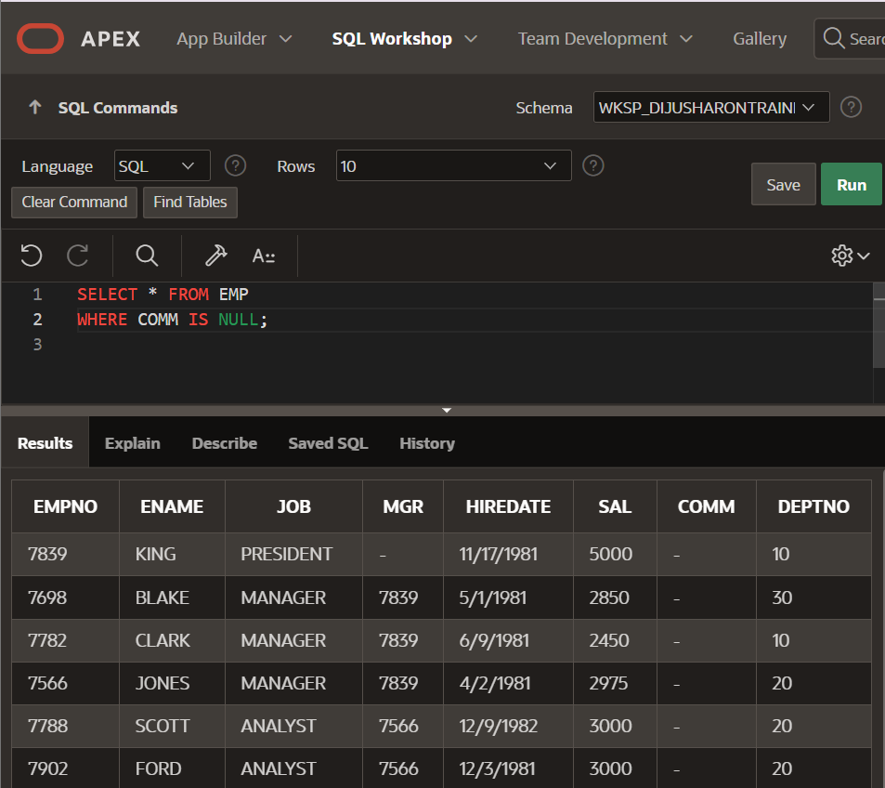

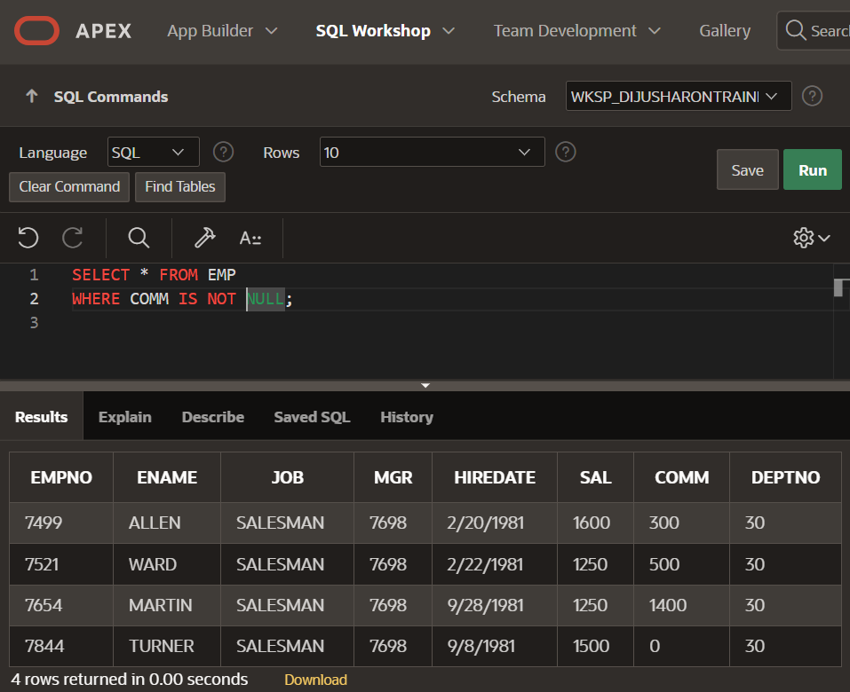

COMBINATION OF OPERATORS AND CLAUSES

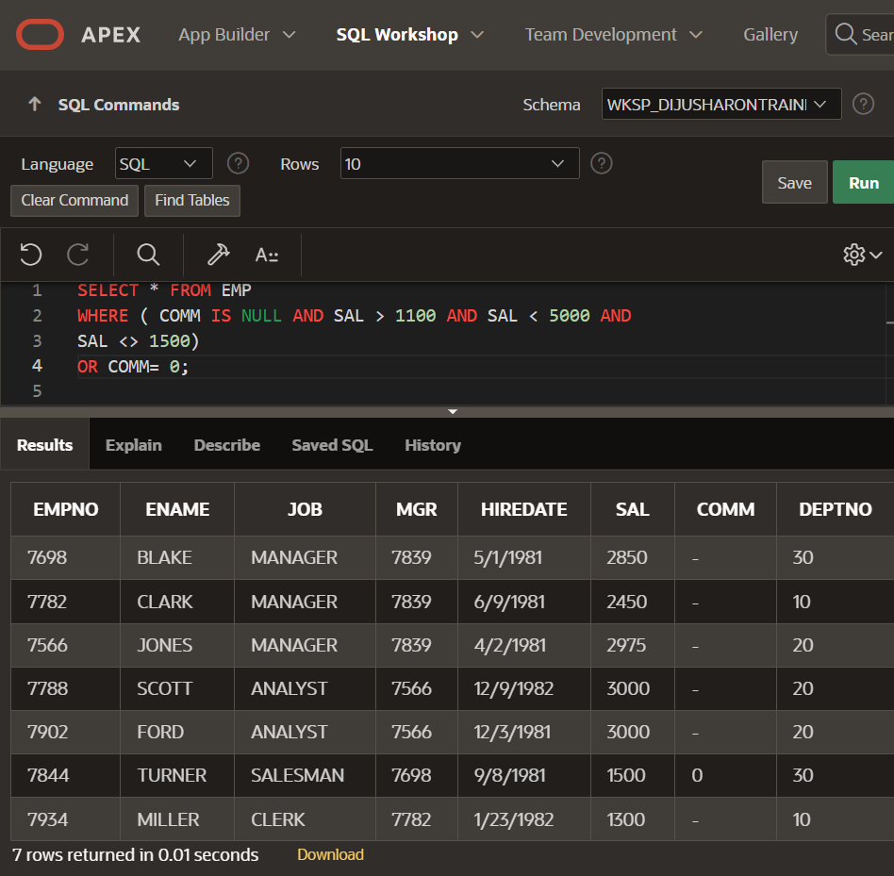

GIVING MEANINGFUL COLUMN NAMES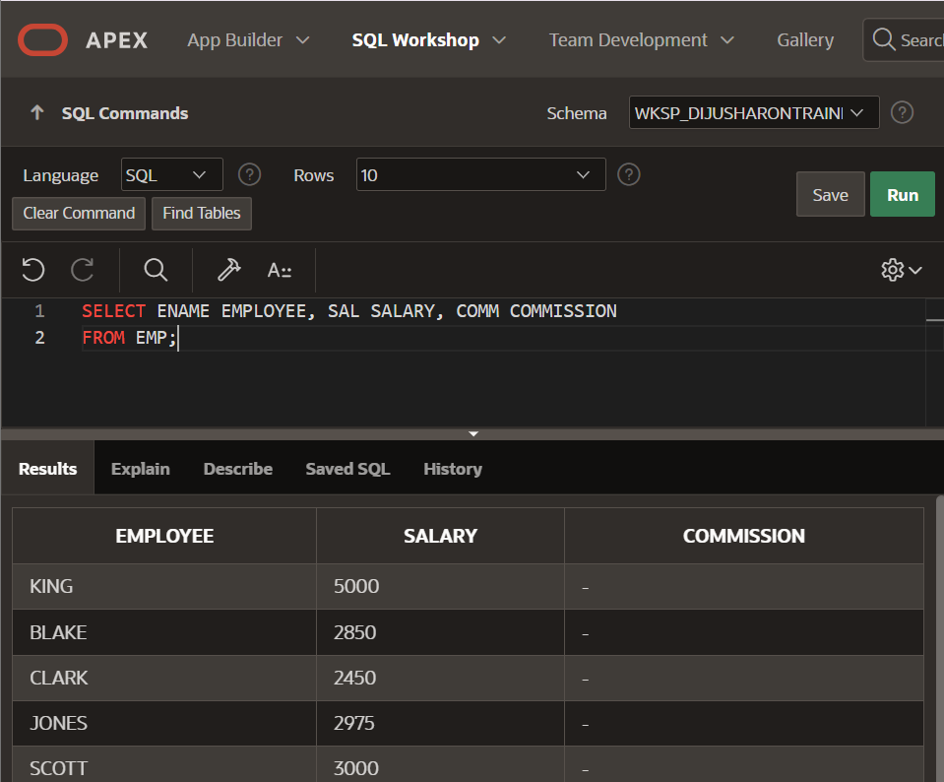

ALIASES

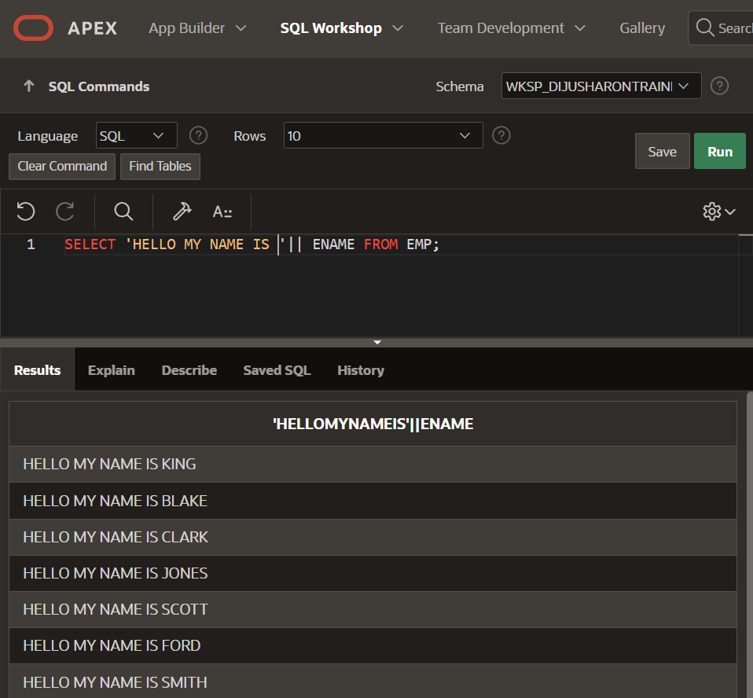

USING THE NVL FUNCTION

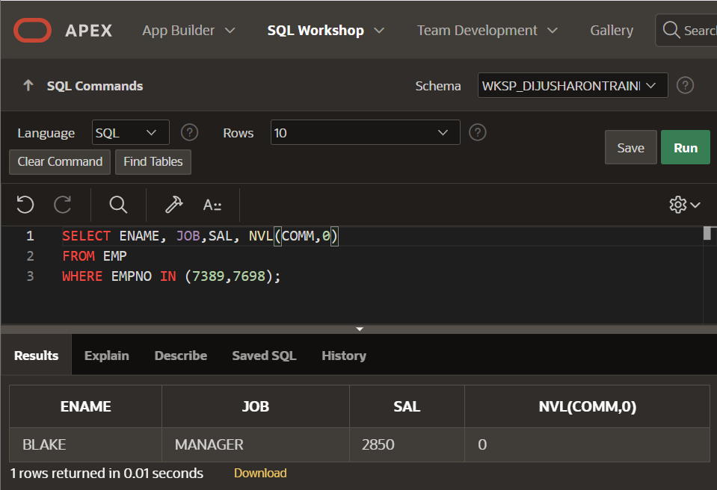

USING THE NULLIF FUNCTION

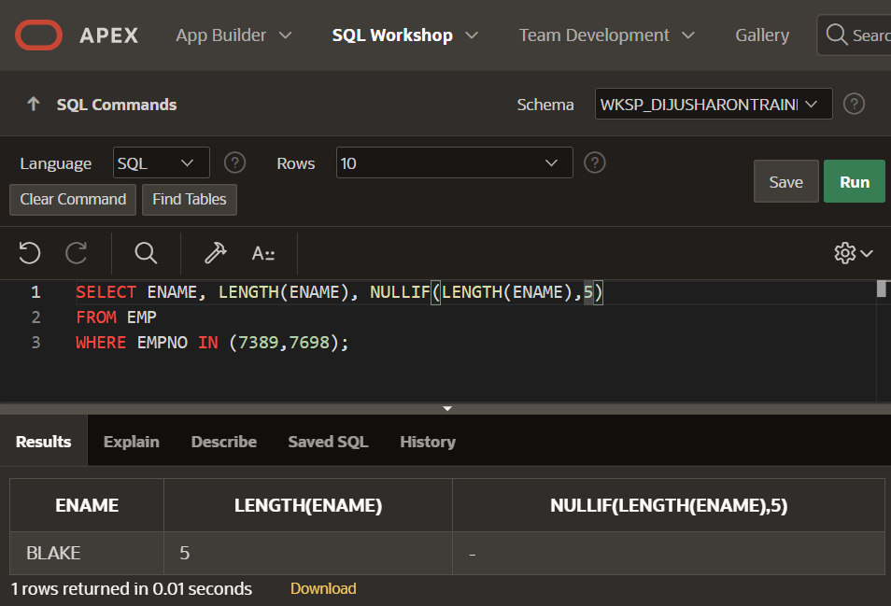

USING MAX, MIN, AVG FUNCTIONS

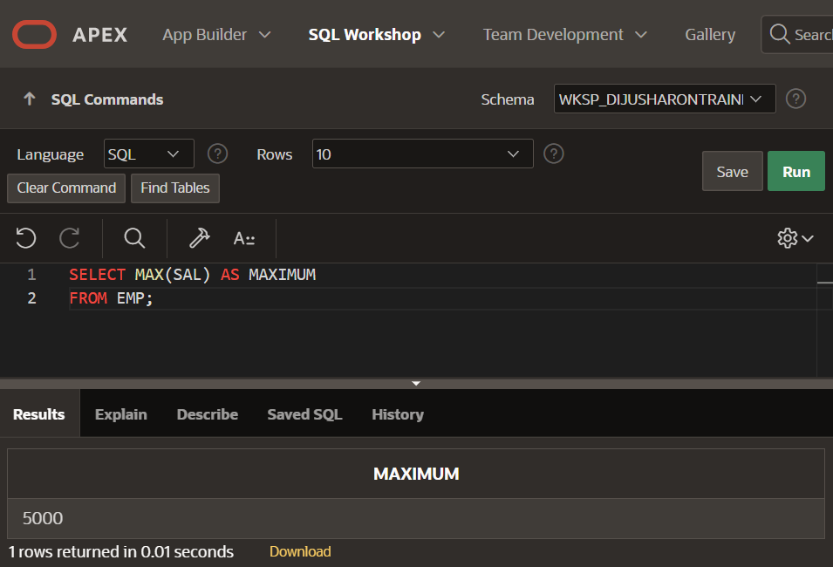

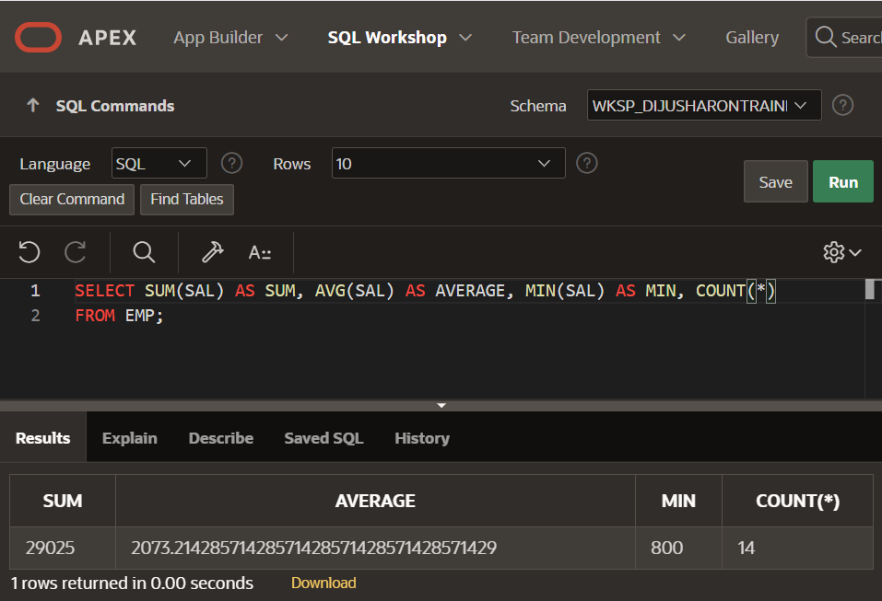

GROUP BY

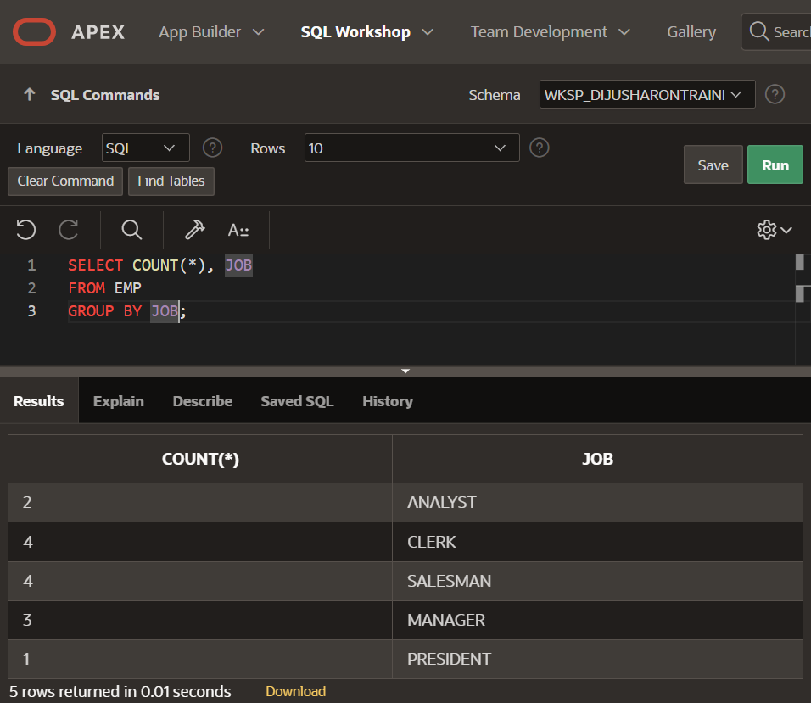

SELECT WITHIN SELECT

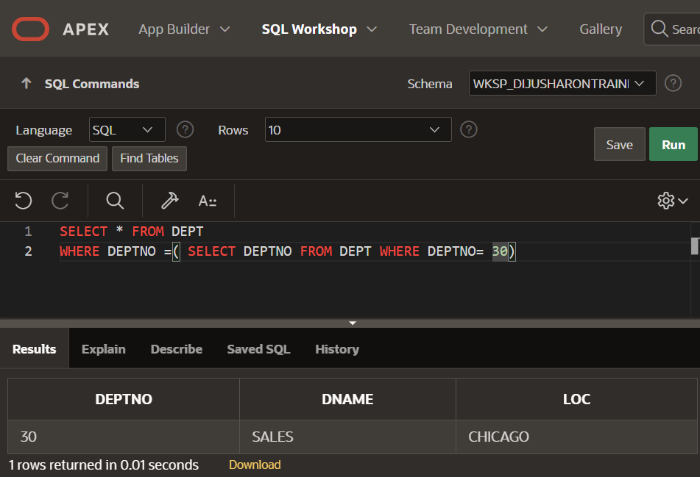

USING JOINS

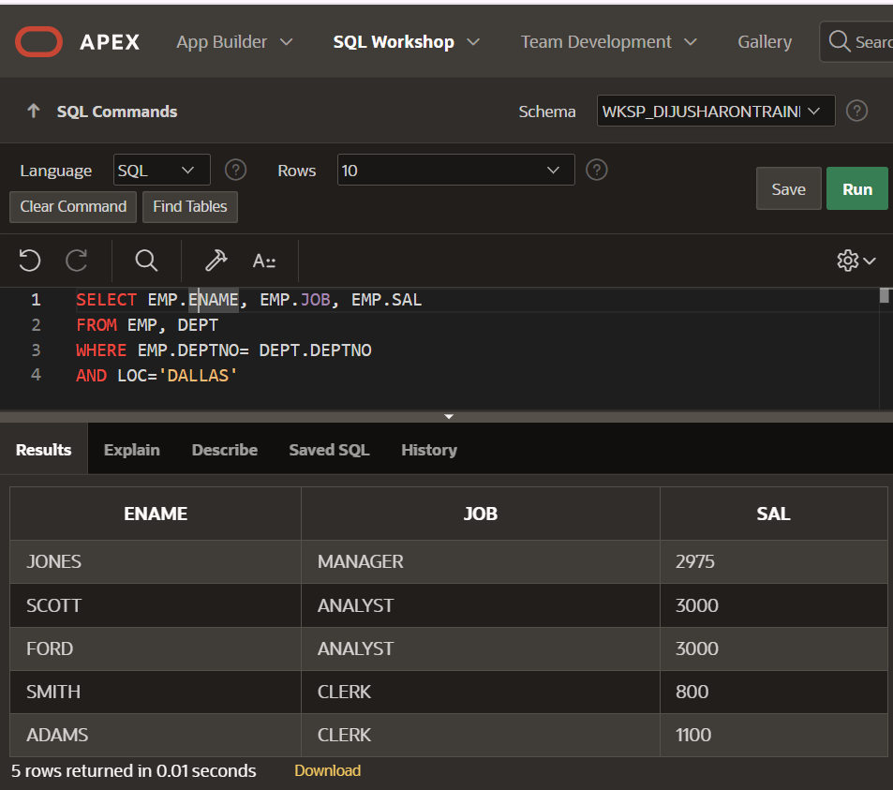

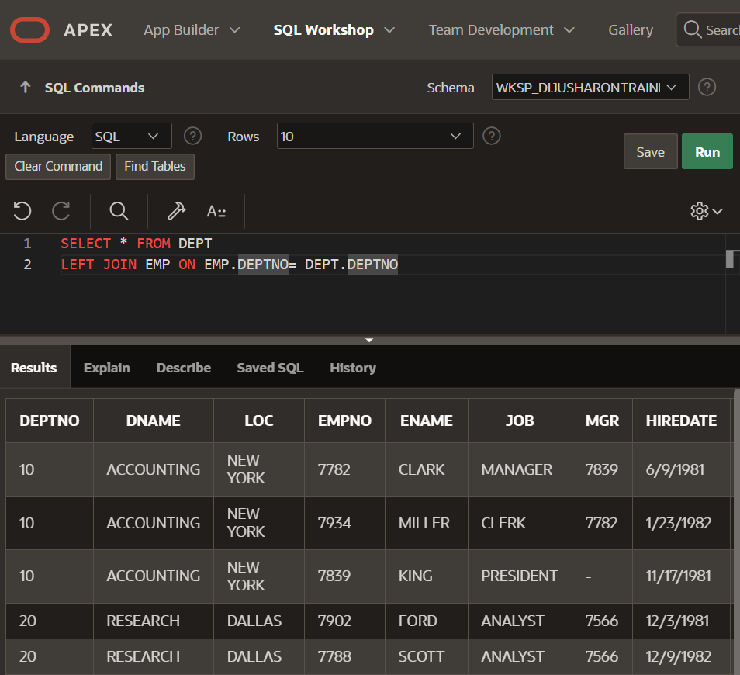

USING SELECT WITHIN SELECT AND JOINS

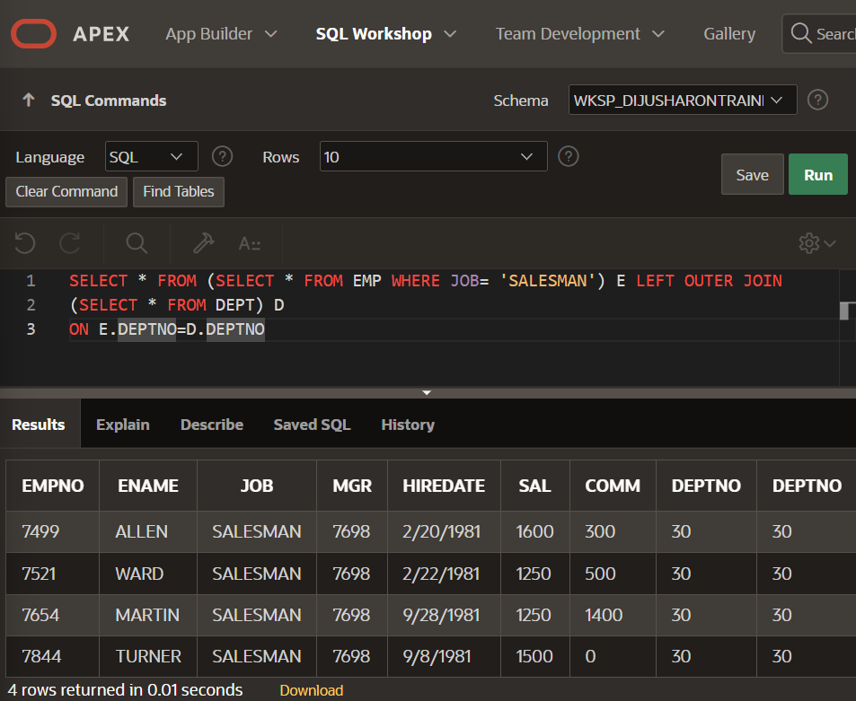

USING WHERE EXISTS AND WHERE NOT EXISTS

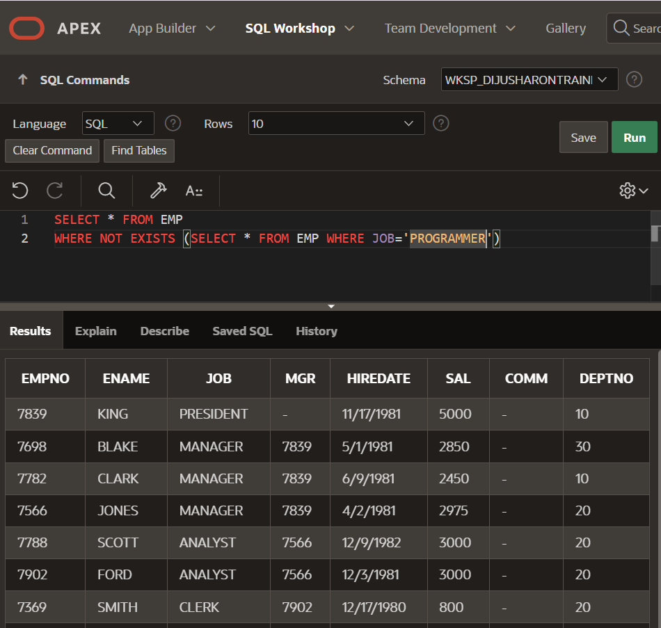

USING SELF JOIN

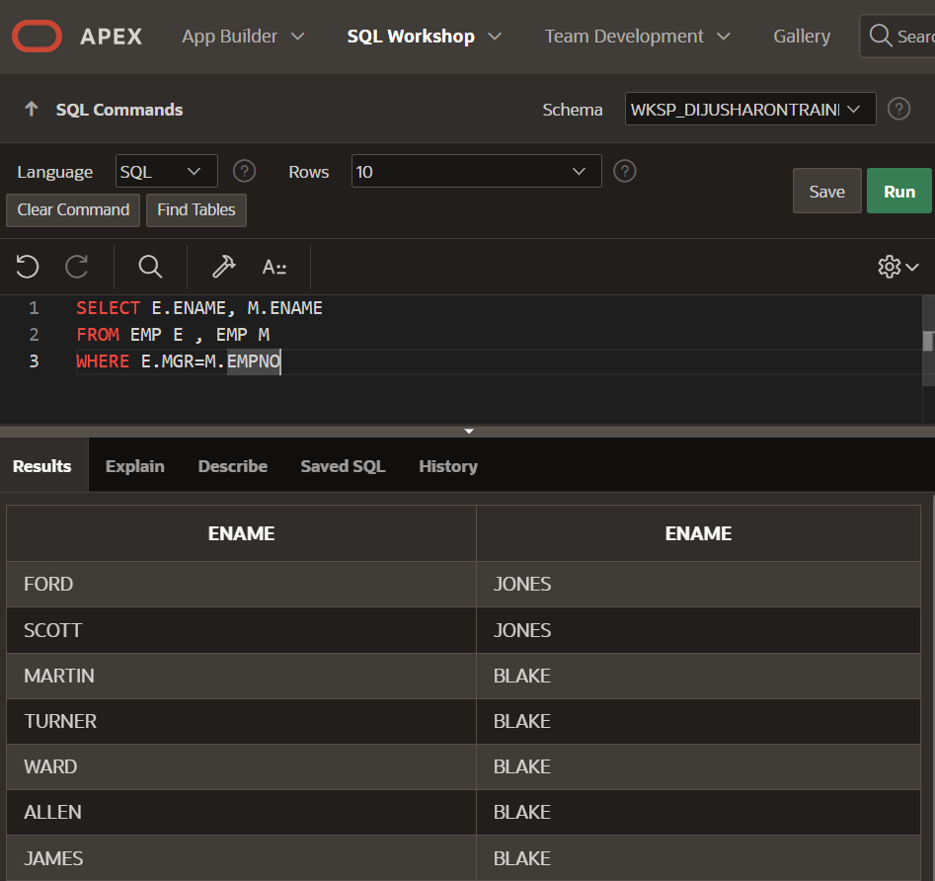

USING CROSS JOIN

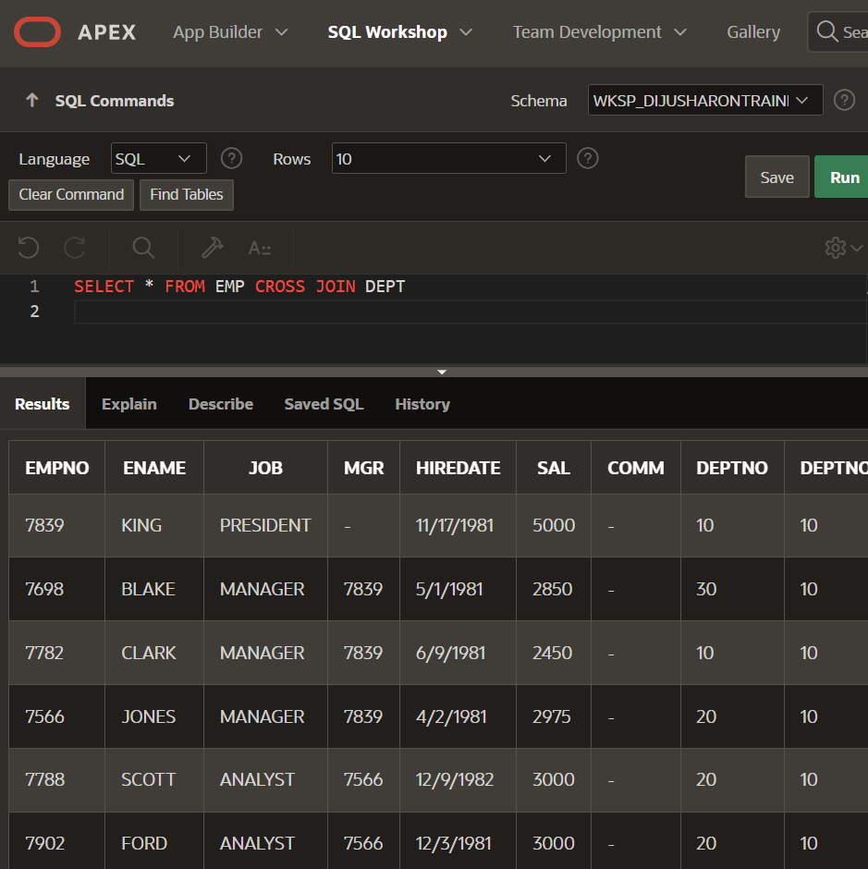

USING CASE FUNCTION AND CONDITIONS

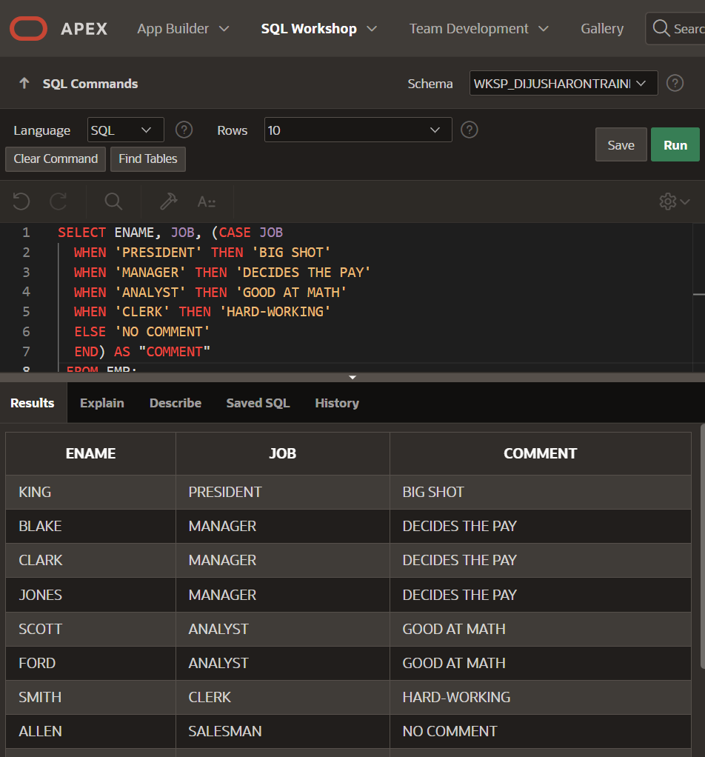

SLIDING WINDOW CONCEPT: CURRENT ROW WEIGHT + THE PREVIOUS ROW WEIGHT

CREATING, INSERTING VALUES AND USING PRIMARY KEY

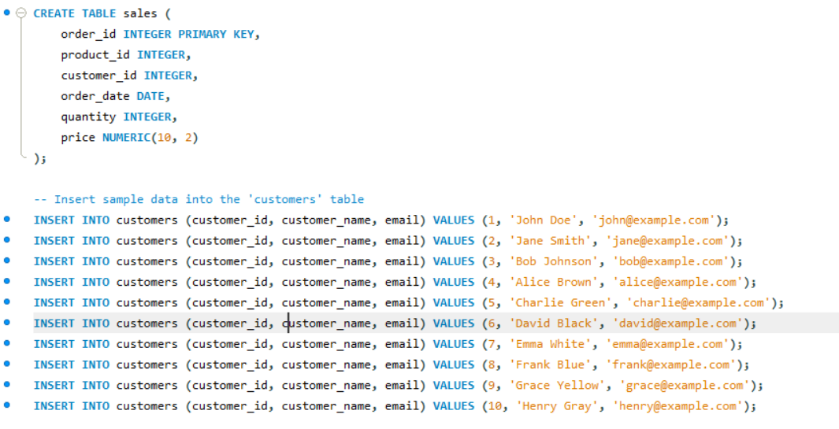

TABLE CREATION

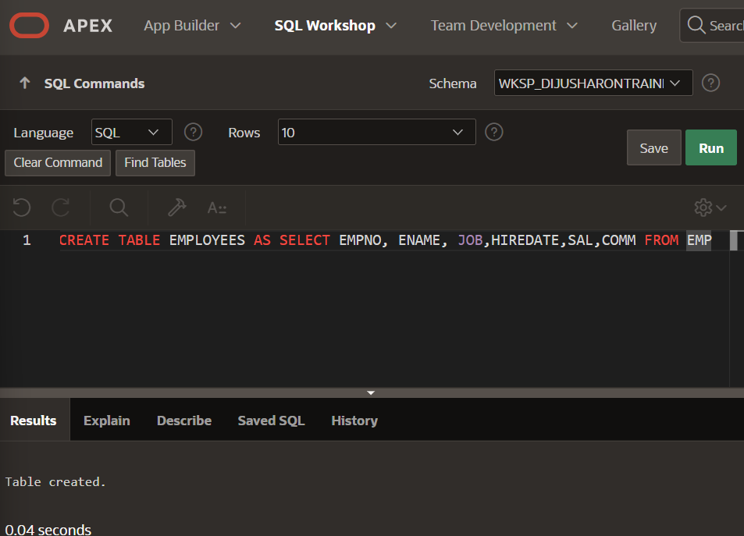

DESCRIBING TABLE

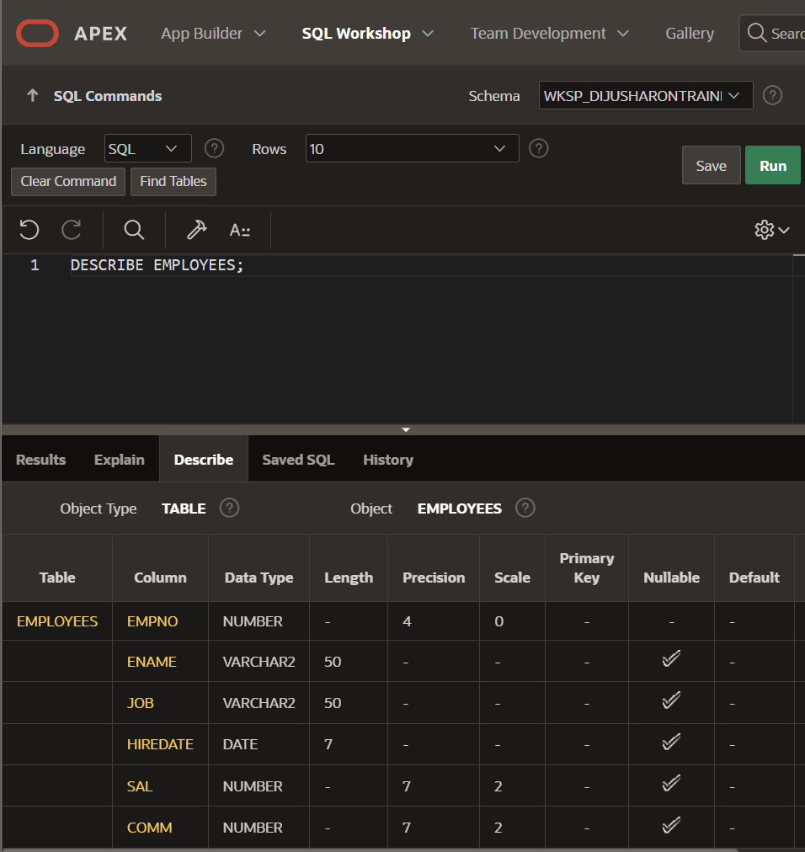

ALTERING TABLE AND ADDING COLUMNS

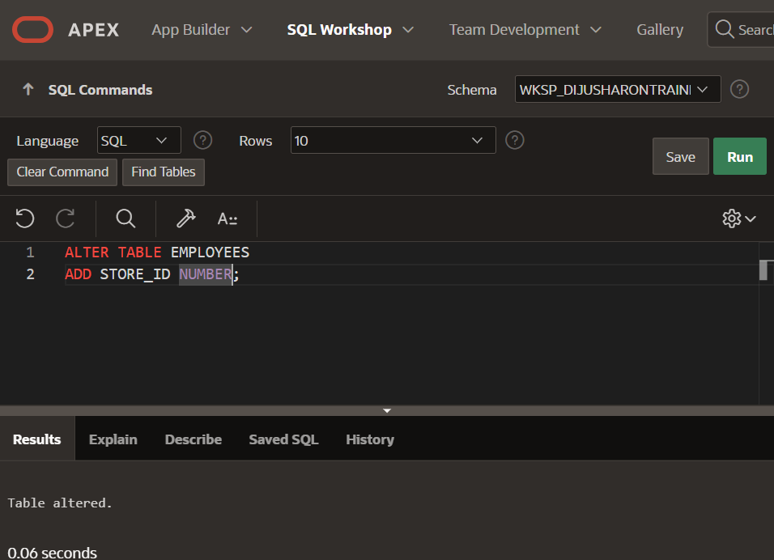

CREATING INDEX

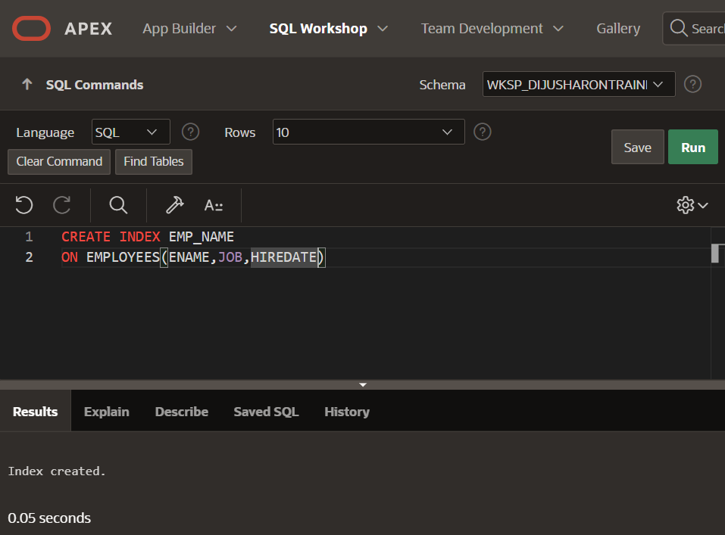

USING THE FETCH CLAUSE

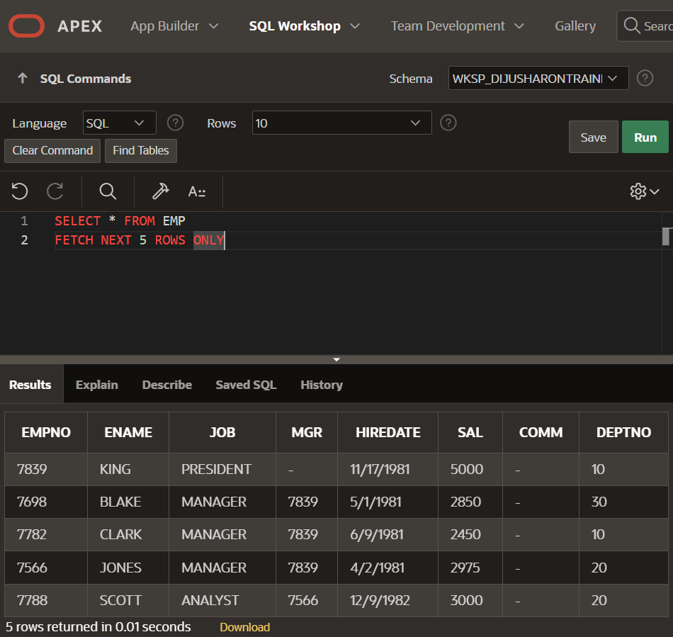

OFFSET: SKIPS THE NUMBER OF ROWS TO THE STARTING ROW NUMBER

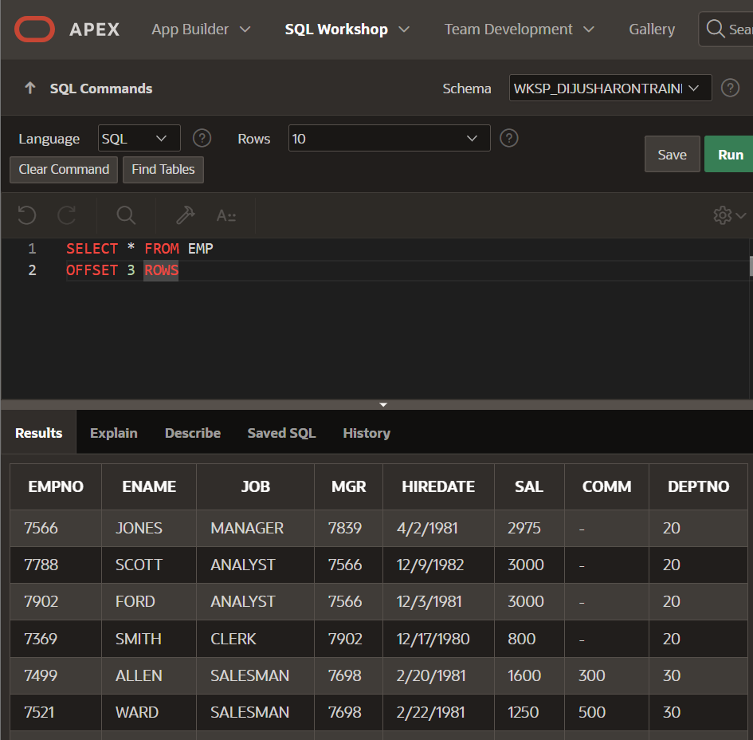

COMMIT COMMAND

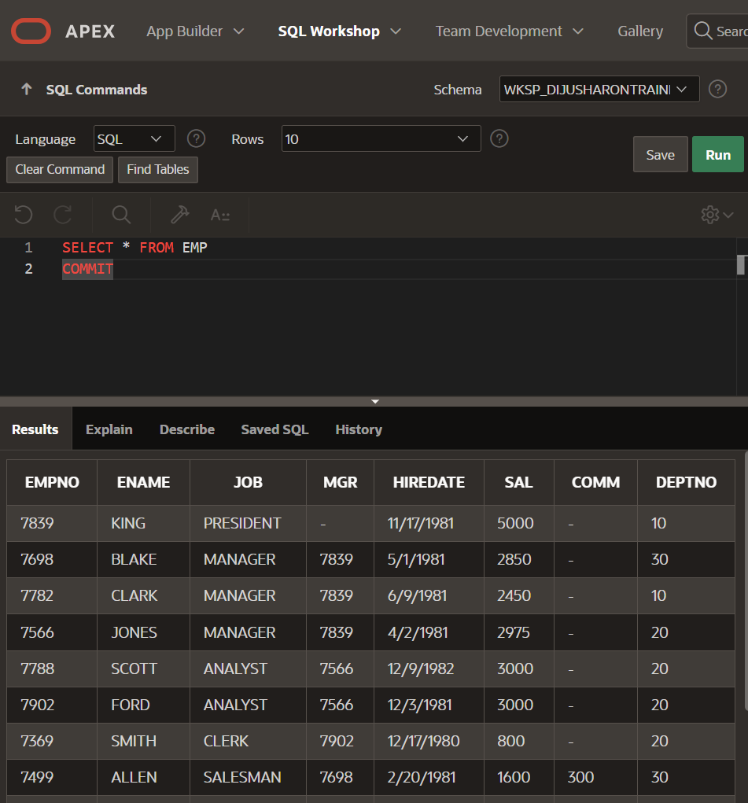

DROP COMMAND

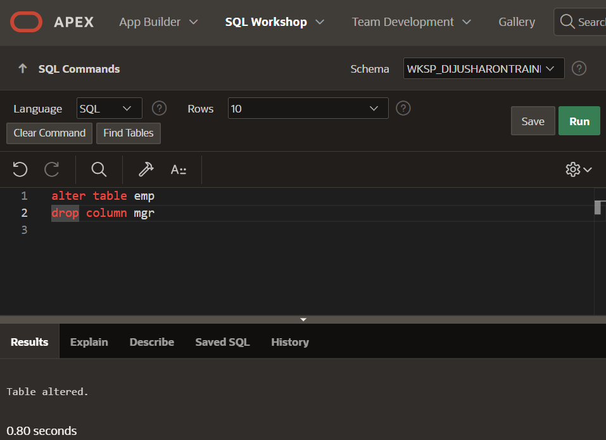

UNUSED COLUMN COMMAND

